Nissan 1400 Bakkie
made by Pieter Steyn
e-mail: mayamodels@yahoo.com

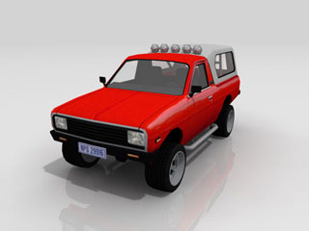
Model Detail:

Maya v6.0 (*.mb / *.ma)

Total Number of Polygons: 2523
Total Number of Polygons (Triangulated): 6078
Total Number of Verts: 3139
Total Number of Edges: N/A
Total Number of UV’s: N/A

Model Description: (Nissan 1400 Bakkie)
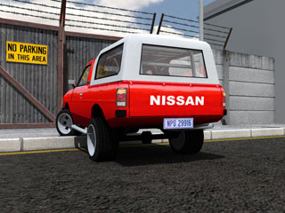
Engine : Texture
Suspension : Texture
Interior : Yes
Sound System : N/A
Rims : Allow Rims
Custom Kit : N/A
Opening Doors : N/A
Opening Hood : Yes
Opening Trunk : Yes
Textures : Yes

Comments:

Please feel free to e-mail me with any comments / questions regarding any model you have downloaded.
You can also make a request for model/s that you need.
Please submit your rating for the downloaded model.
Search for more models by typing in “copycatz” in the search bar at www.turbosquid.com

